THE EFFECT OF DIFFERENT STIMULI ON MEAGRE Argyrosomus regius FEEDING BEHAVIOUR.

Ioannis E. Papadakis*¹, Nikos Papandroulakis¹, Alkioni Sfendouraki², Veronica Camporesi³, Manolis Vasilakis¹, Constantinos C. Mylonas¹.

¹Institute of Marine Biology, Biotechnology and Aquaculture, Hellenic Center for Marine Research, Aqualabs, Thalassokosmos, P.O.Box, 2214, Iraklion Crete, Greece 71003. Email: papad@hcmr.gr
²Biology Department, University of Crete, P.O. Box 2208 Heraklion 714 09 Crete, Greece.
³Università di Bologna, corso di laurea in Acquacoltura eigiene delle produzioni ittiche. Via Doria, 5 Cesenatico (FC) Italy

Introduction
Meagre is a relatively new species for the Mediterranean aquaculture, and has a high potential due to its high productive and commercial characteristics. Although effective methods for the meagre larval rearing have been developed, issues related with its behavior during on growing in cages require further research. In nature, meagre inhabit areas close to the sea bottom and this activity is related to its mouth position and slow swimming activity. A similar feeding behavior is expressed during cages rearing, where meagre groups are mostly concentrated at the lower section of the cage. This behavior makes feeding problematic, because the rearing population is not visible by the personnel of the farms during the feeding procedure, a fact that results in feed loss, high feed conversion ratios and eventually increased production costs. The learning ability of fish is well known (Bitterman, 1984), based on the results from a variety of studies in different fish species that have been performed using stimuli for the attraction of individuals to a particular region (Bratland et al. 2010). Similar behavioral studies for the meagre have not been performed until now. The aim of this study was to evaluate the effect of two different stimuli (light and air bubbles) on feeding behavior of meagre. The knowledge t extracted could be used for the development of a feeding method for cage farming in order for the feeding management to be more effective.

Materials and methods
Two stimuli conditions were tested and compared to a control group without stimulus. The first stimulus was a fading light coming from LED lamps and the second was air bubbles from a tube at the bottom of the tank. The experiment lasted for 60 days and was carried out during the period of May-June 2016 in Crete, in duplicate outdoor 10m³ tanks that were exposed to natural light conditions. The experimental population consisted of 10 individuals with initial average weight of 650±45g in each tank. Each stimulus lasted for 45sec. Five seconds before the stimuli stopped, an automatic electric feeder was activated. Feedings were performed three times per day at 07:30, 12:30 and 18:30. A recording system equipped with cameras recorded video data for 5 minutes before, after and during the feeding periods and at 10:30 and at 15:30. From each 5-minute video 70 pictures were extracted. In each picture the area of the tank was divided to six equal surface subareas (Fig. 1a) and the head from each fish was pointed manually using the image J programme. The coordinates of each fish were used for the determination of the region where the fish were at different times.

Results and discussion
During the morning (Fig. 1b) and afternoon (Fig. 1c) the stimuli of light and air bubbles attracted the experimental population to the feeding area (p<0.05). At noon, air bubbles attracted the experimental population to the feeding area (Fig. 1b) more than light (p<0.05). Meagre during low sunlight intensity (morning and afternoon) exhibited higher motility and were distributed throughout the tank. During the period of high light intensity (noon), fish preferred to stay more in the shaded areas of the tank than in the areas exposed to direct sunlight. According to the obtained results, meagre learned to associate the feeding procedure with both light and air bubbles and were gathered in the feeding area during their use. Both stimuli have been shown to attract various fish species to particular areas (Bratland et al., 2010). The low response to light stimuli at noon is connected with the low visibility of the light stimuli at the time of high direct sunlight. The different pattern of fish motility during the morning and afternoon, and the preference to the darkest areas of the tank during noon are associated with the particular behavioral patterns of meagre.

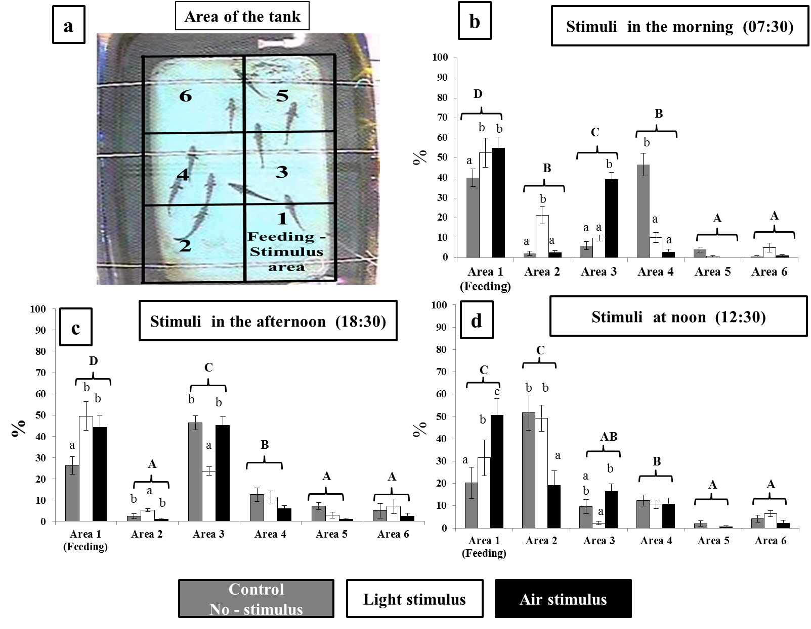
Figure 1. Organization of different subareas of the tank (a) and the percentage distribution of fish in the different areas in the morning (b), afternoon (c) and noon (d). Uppercase letters indicate differences between the different areas and lowercase letters indicate differences between conditions for each area (two-way ANOVA, Duncan’s New Multiple Range test, P<0.05).

Conclusions
Both air bubbles and light, or combinations of them can be used in an industrial setting to attract meagre to the feeding area, in order to be visible by the farm personnel or monitoring system, thus resulting in more efficient feeding and better growth. Both training stimuli can be used and managed easily with existing technologies in sea cages.

References
Bitterman, M. E. (1984). Migration and Learning in Fishes. In J. D. McCleave, Mechanisms of Migration in Fishes New York, NY: Plenum Press. pp. 397–420
Bratland, S., Stien, L. H., Braithwaite, V. A., Juell, J. E., Folkedal, O., Nilsson, J., and Kristiansen, T. S. (2010). From fright to anticipation: using aversive light stimuli to investigate reward conditioning in large groups of Atlantic salmon (Salmo salar). Aquaculture international, 18(6), 991-1001.

Acknowledgments
Co-funded by the Seventh Framework Programme
of the European Union
This project has received funding from the European Union’s Seventh Framework Programme for research, technological development and demonstration (KBBE-2013-07 single stage, GA 603121, DIVERSIFY).

