

**Deliverable Report**

|  |  |  |  |
| --- | --- | --- | --- |
| **Deliverable No:** | D1.1 | **Delivery Month:** | 24 |
| **Deliverable Title** | This is the full title of the Deliverable as it was written in the DOW. It should be descriptive enough to show the full scope of the deliverable and all the necessary details. | | |
| **WP No:** | 1 | **WP Lead beneficiary:** | P1. HCMR |
| **WP Title:** | Title of WP from DOW | | |
| **Task No:** | 1.1 | **Task Lead beneficiary:** | P1. HCMR |
| **Task Title:** | This title should come from the DOW and should be complete and descriptive. | | |

|  |  |  |  |  |
| --- | --- | --- | --- | --- |
| **Other beneficiaries:** | P2. FCPCT | P3. IRTA | P4. IOLR | P5. UNIABDN |
| P6. DLO | P7. IMR | P8. IEO | P9. UL | P10. TU/e |
| P11. AU | P12. APROMAR | P13. UNIBA | P14. IFREMER | P15. ULL |
| P16. FUNDP | P17. NIFES | P18. CTAQUA | P19. CMRM | P20. SARC |
| P21. DTU | P22. SWH | P23. ARGO | P24. ITICAL | P25. DOR |
| P26. GEI | P27. FORKYS | P28. CANEXMAR | P29. ASIALOR | P30. CULMAREX |
| P31. IRIDA | P32. MC2 | P33. FGM | P34. BVFi | P35. MASZ |
| P36. ANFACO | P37. EUFIC | P38. HRH |  |  |

|  |  |  |  |
| --- | --- | --- | --- |
| **Status:** | Delivered/delayed | **Expected month:** | 48 |
| ……….. | | | |

**Lead Scientist preparing the Deliverable:** Mylonas, C.C. (HCMR),

**Other Scientists participating:** Corriero, A. (UNIBA), Duncan, N. (IRTA)

**Objective:** The objective of this Deliverable is to …….

**Description:** Description of the work done and results

Please follow the format instructions below and in the comments:

Font Times New Roman, 11 point

Justified text, except for the figures and tables (centered)

No indentation at the beginning of the paragraph

Single space, 6 points after a paragraph (from “Paragraph” submenu, “Format” menu)

All Tables and Figures **must** be cited in the main text as (**Table ??**) and (**Fig. ?**)

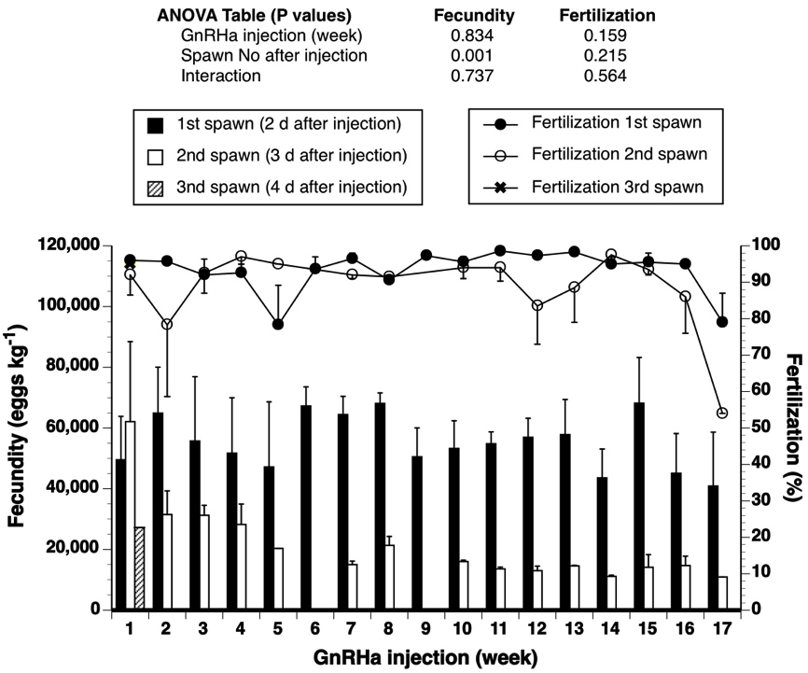

**Figure 1.** Mean (±SEM) daily batch fecundity and fertilization of meagre (n=1-4) induced to spawn with GnRHa injections (n=17, once every week) during 2014. The two-way ANOVA (GnRHa injection number vs Spawn number after each injection) indicated the existence of a significant interaction (P=0.001) in fecundity only, while the two main factors did not have any significant effect (either in fecundity or fertilization). Linear regression analysis indicated the existence of a significant negative relation between GnRHa injection number and fecundity for the 2nd spawn data (n=32, R2=0.37, P =0.001, data not shown).

**Table 1.** Biometric and treatment data of all meagre breeders used in the spawning induction studies, at the time of hormone administration. The mean oocyte diameter represents the largest vitellogenic oocytes at the time of treatment. All fish were treated with an EVAc GnRHa implant, and variations in the effective GnRHa dose were due to the fact that implants were loaded with fixed amounts of GnRHa



**Deviations:** If any, explain the deviations, their impact on the deliverable and project overall



Co-funded by the Seventh Framework Programme

of the European Union