DIVERSIFY - Task progress update
WP No: | 3 | WP Lead beneficiary: | 13
WP Title: | Reproduction & Genetics – greater amberjack (Please use the title as it appears in the DOW)
Task No: | 3.2 | Task Lead beneficiary: | 1
Task Title: | Development of an optimized spawning induction protocol for captive greater amberjack in the Mediterranean (Please use the title as it appears in the DOW)

Objective: Compare two different GnRHa administration methods to induce spawning.
Description: The experiment was held in the facilities of ARGOSARONIKOS FISHFARMING (ARGO) in Salamis, Greece (Fig. 1) on June 2016 and compared controlled release delivery systems (implants) loaded with GnRHa and weekly GnRHa injections to induce spawning. A total of 14 males and 14 females were allocated in four tanks and females received on of the two spawning induction therapy. All males were implanted with GnRHa (Day 0) to ensure adequate sperm production. Three weekly GnRHa injections (Days 0, 7 and 14) and two GnRHa implants (Day 0 and 14) were applied to the females. Eggs were collected three times a day (Fig. 1), and fecundity and fertilization success were evaluated. In order to monitor embryo and larval survival, eggs were placed individually in 96-well microtiter plates (n=2). Then, eggs were transferred in egg incubators until their shipment to hatchery for larval rearing.
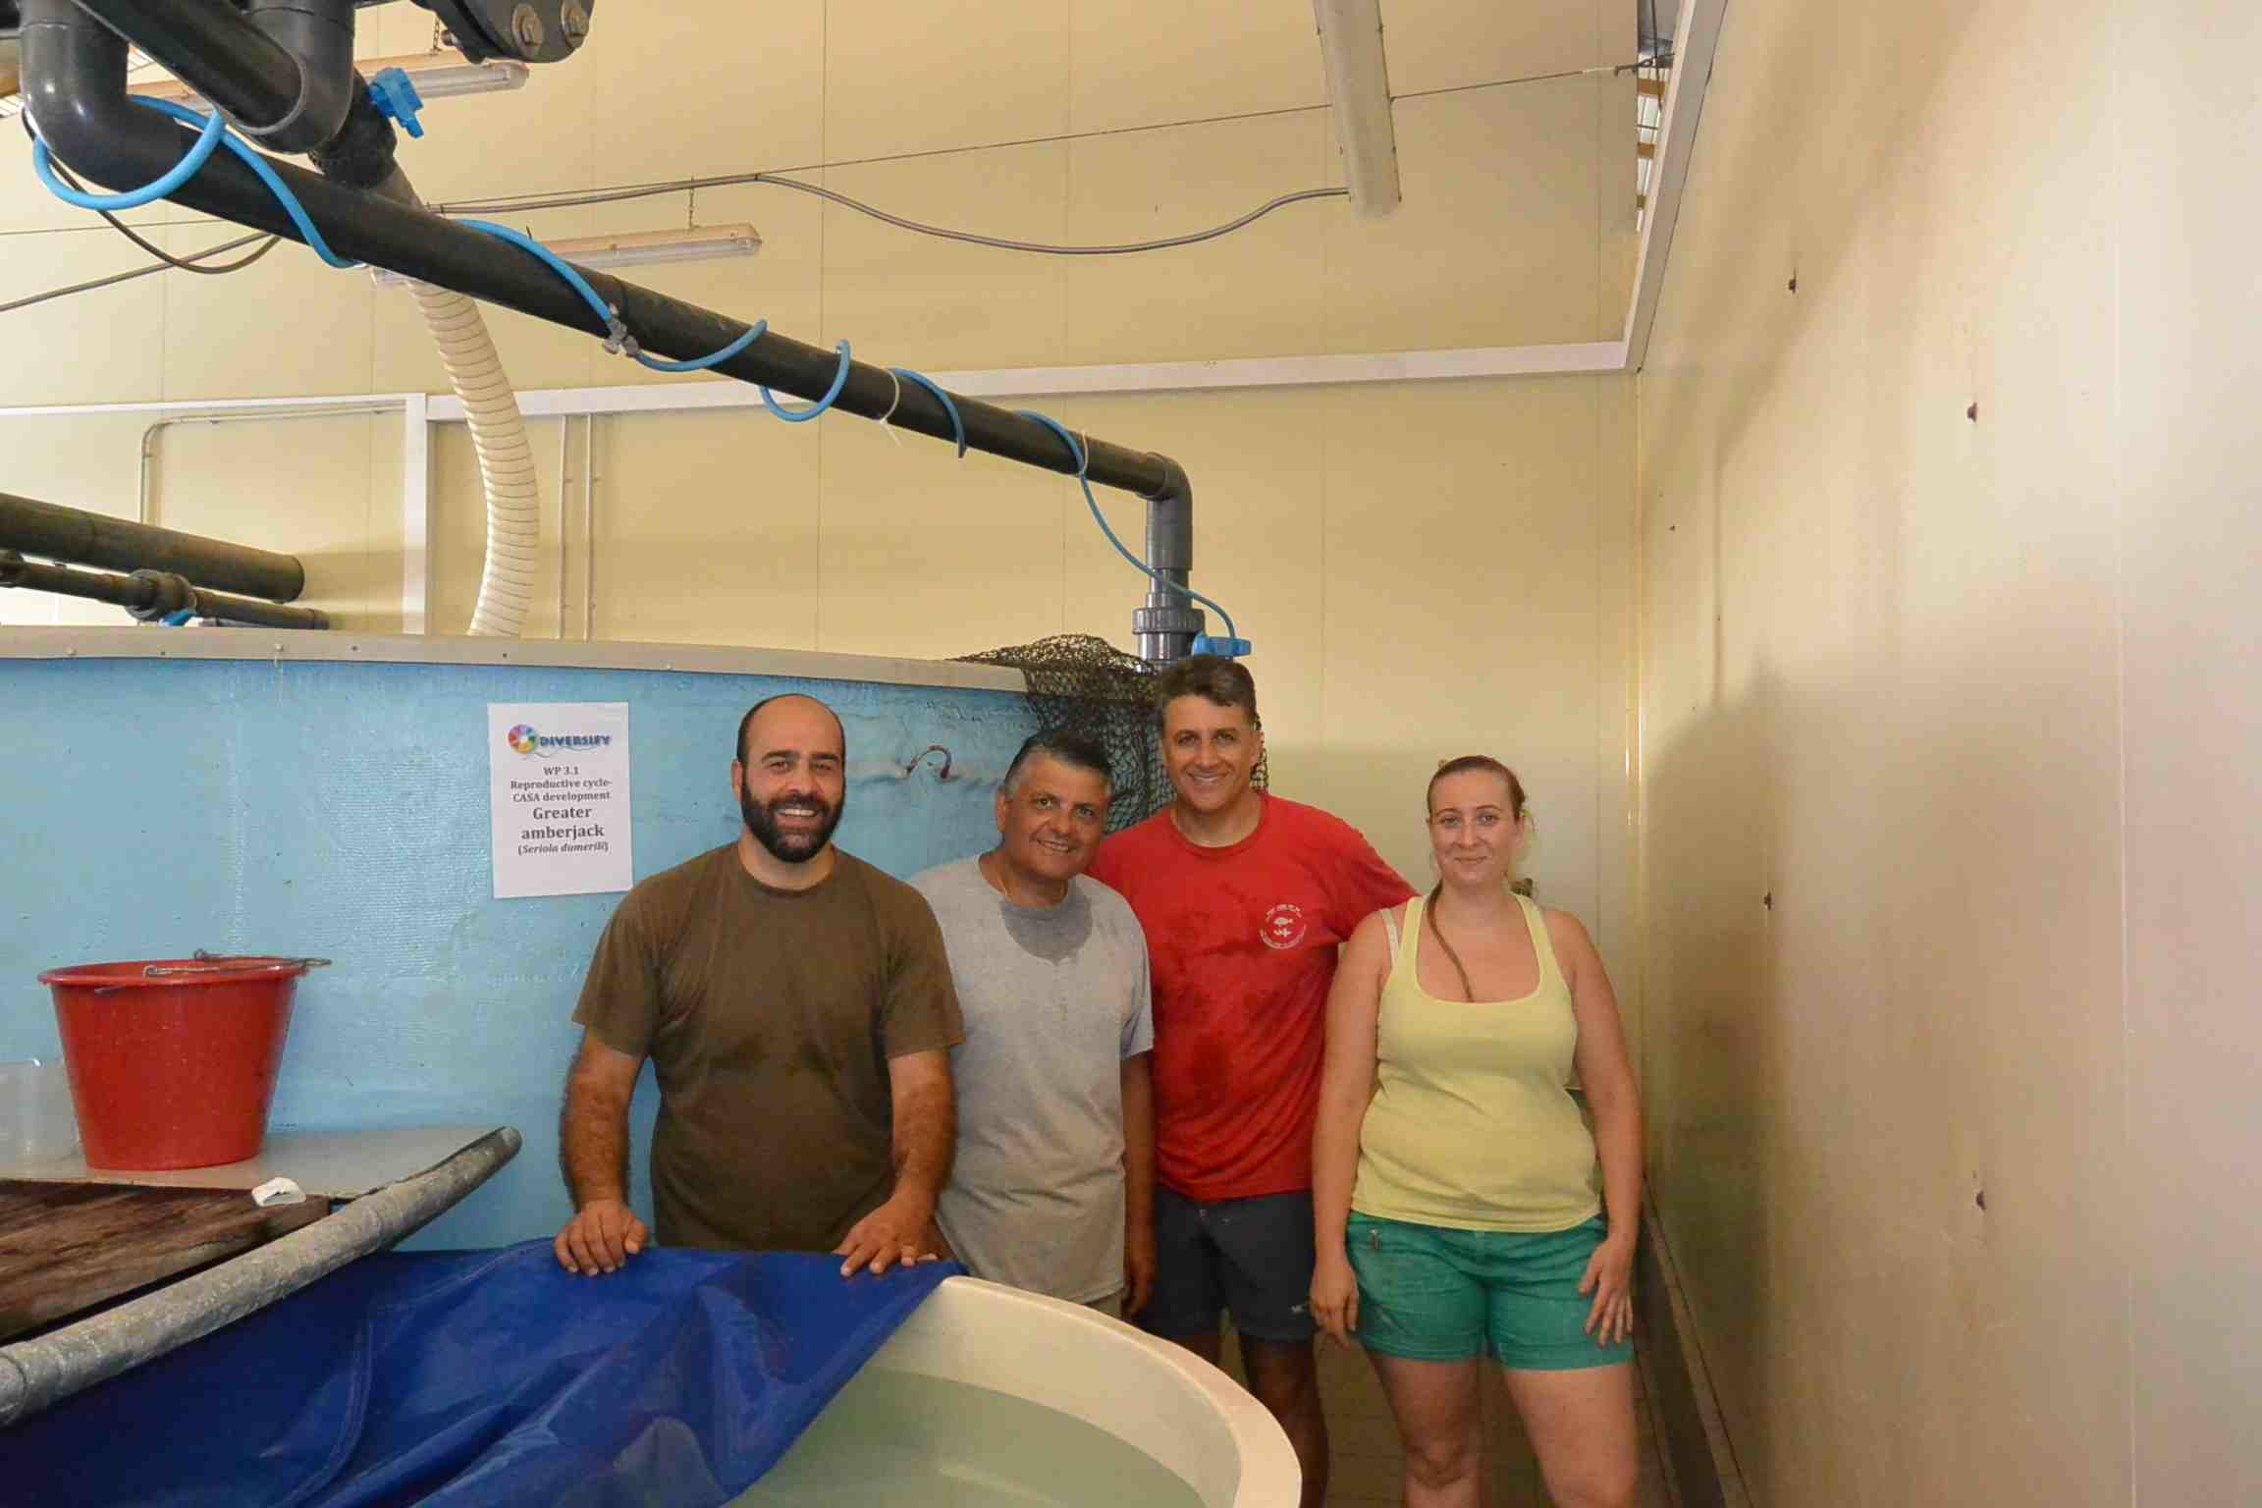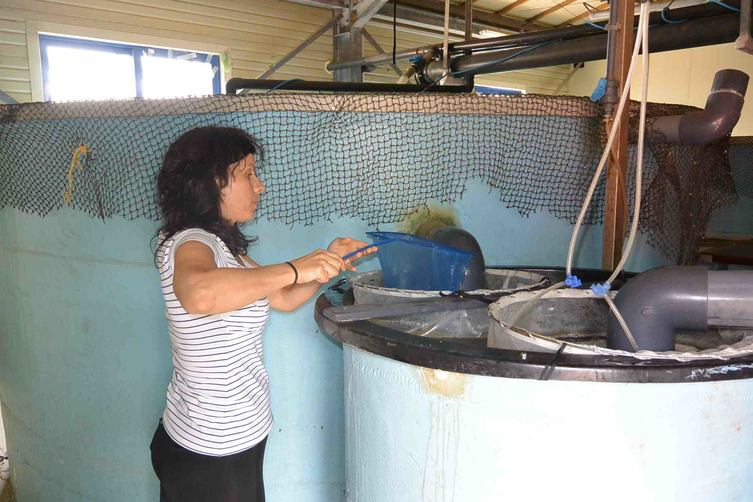
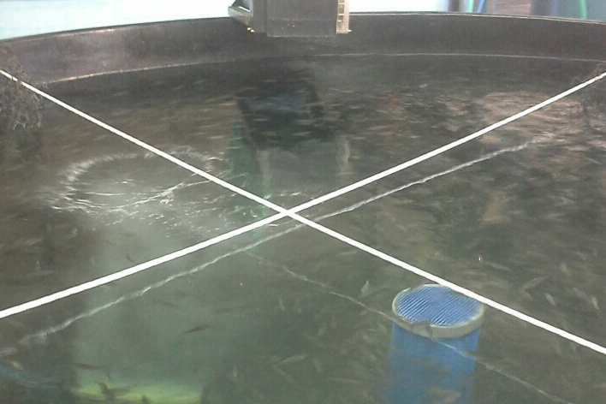
Figure 1. The sampling team (left) and collection of eggs at the ARGO facilities (right). Greater amberjack juveniles at the ARGO facilities (bottom), obtained from the larval rearing trials at HCMR.
Results: The GnRHa implants were more effective compared to GnRHa injections in terms of daily egg fecundity and total egg fecundity. The mean daily egg production was 15,231±2,295 eggs kg⁻¹ fish for GnRHa implants compared to 6,119±885 eggs kg⁻¹ fish for GnRHa injections (Table 1) and the total egg production was 27 millions and 10.5 millions eggs, respectively. There were no differences among the mean fertilization success of the two GnRHa administration methods, which were 38% for GnRHa implants and 34% for GnRHa injections, respectively. The same was observed for embryo survival, hatching and 5-day larval survival (data not shown).
Eggs were shipped to the HCMR hatchery in Crete, Greece for larval rearing, weaning and grow out experiments. Eggs were also shipped to different hatcheries in Greece and Cyprus in order to test different rearing protocols. More than 100,000 juveniles were produced at the HCMR hatchery, which is the highest number of greater amberjack juveniles ever produced in Europe so far. This successful year for greater amberjack aquaculture was completed with the transfer of a significant number of juveniles to various farms (Fig. 1), in order to test the sea-cage on-growing of fish in commercial conditions.
In conclusion, it was found that GnRHa implants induced a higher daily production of good quality eggs compared to the weekly GnRHa injections. An additional advantage of the GnRHa implants as an administration method was the reduced fish handling, which was once every 2 weeks during the experiment as opposed to every week. In the following years, the planned experiments will focus on verification of the best application time of the GnRHa implant treatment and the optimization of the GnRHa dose. We expect at the end of the project (2018) to deliver a useful spawning induction protocol for the aquaculture industry, which will be a significant step towards the domestication of the greater amberjack.

Table 1. Egg quality parameters (mean±SD) of captive greater amberjack spawning after hormonal administration of either controlled release delivery systems (implants) loaded with GnRHa or GnRHa injections.
 | Spawns | Rel. fecundity  (eggs kg⁻¹ fish per spawn) | Fertilization (%)
GnRHa implants | 13±0 | 15.231±2.295 | 38±3
GnRHa injections | 13.5±0.7 | 6.119±885 | 34±11

